Walkthrough 28 Unit Test with QUnit

https://sapui5.hana.ondemand.com/#/topic/e1ce1de315994a02bf162f4b3b5a9f09

Core Changed Codes Compared to Last Version:

1 test/unit/unitTests.qunit.html 新建UT交互界面

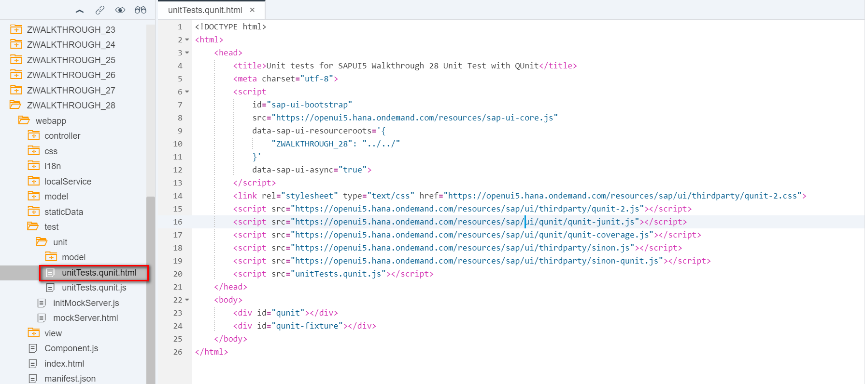

2 test/unit/unitTests.qunit.js 新建UT启动文件

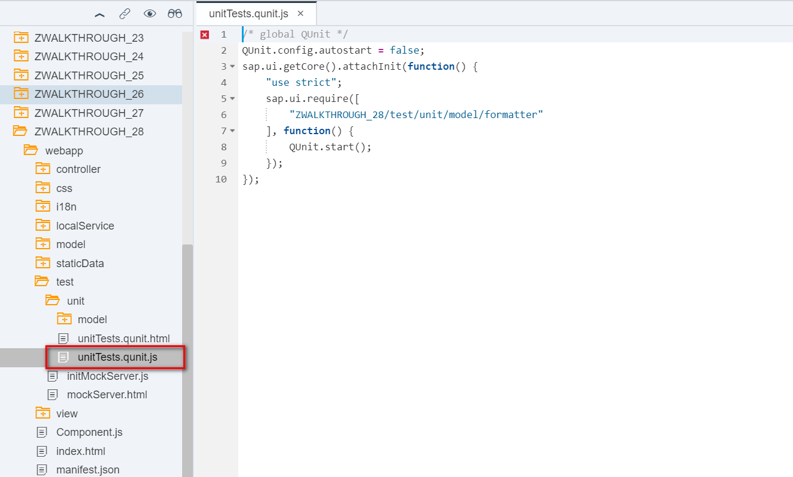

3 test/unit/model/ formatter.js 打桩测试并编写测试脚本代码

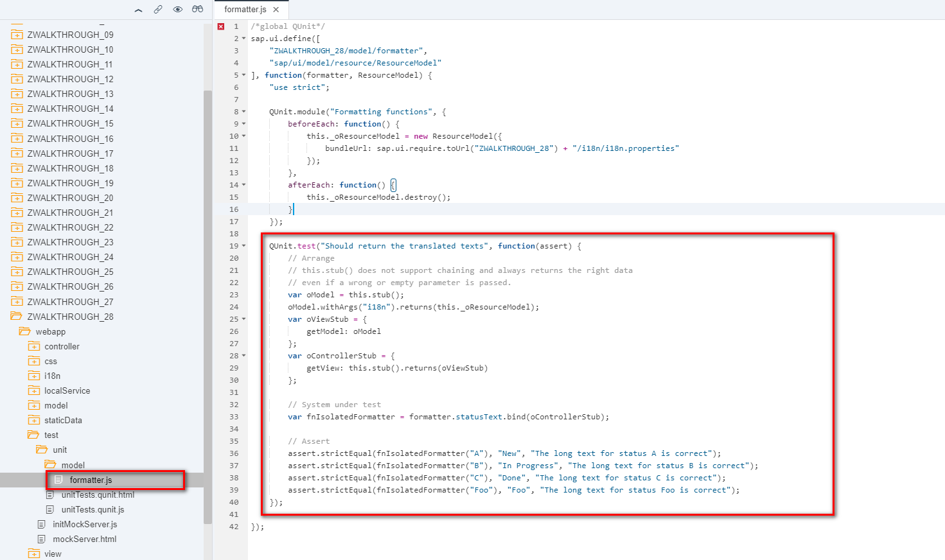

i18n 文本对象管理

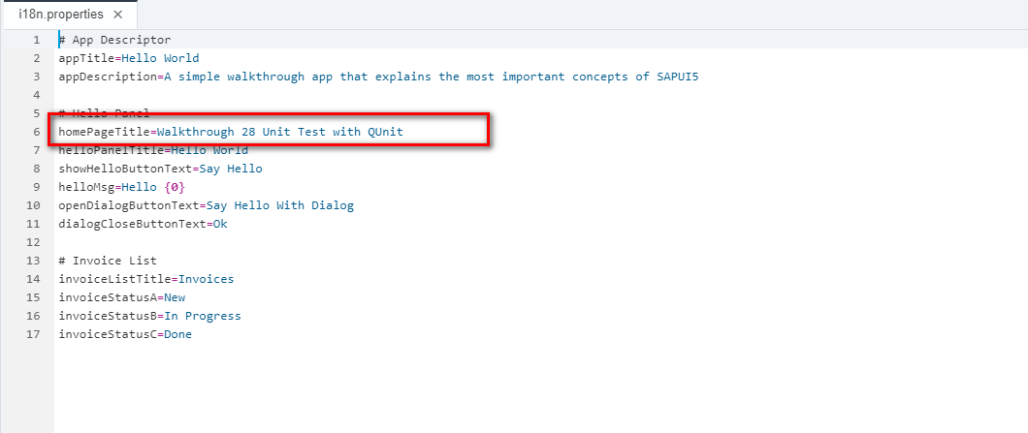

Result

Positive

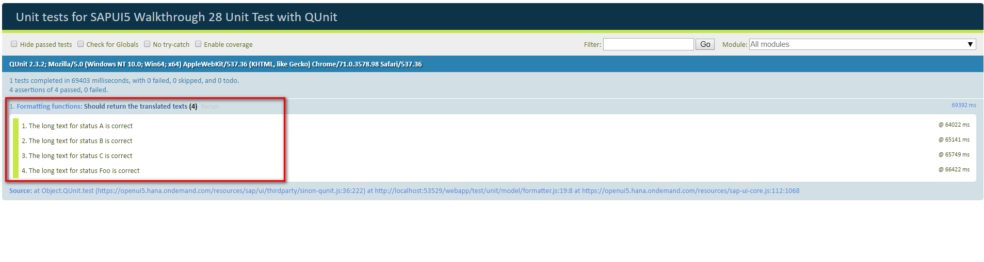

Negative

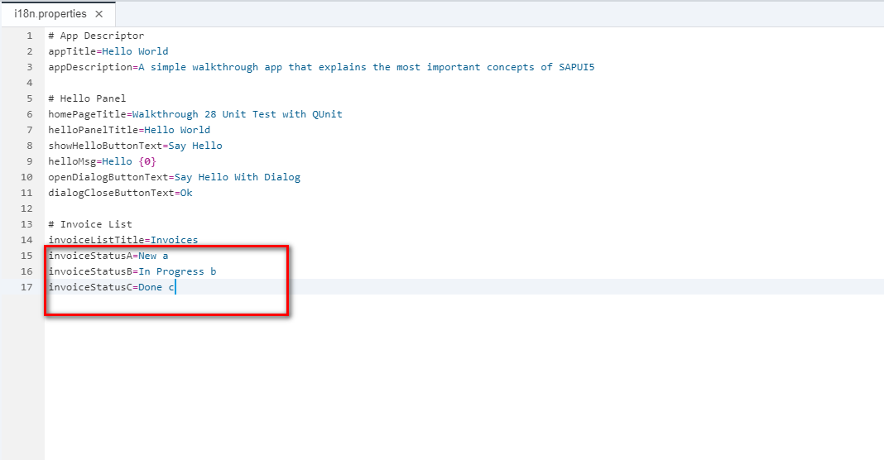

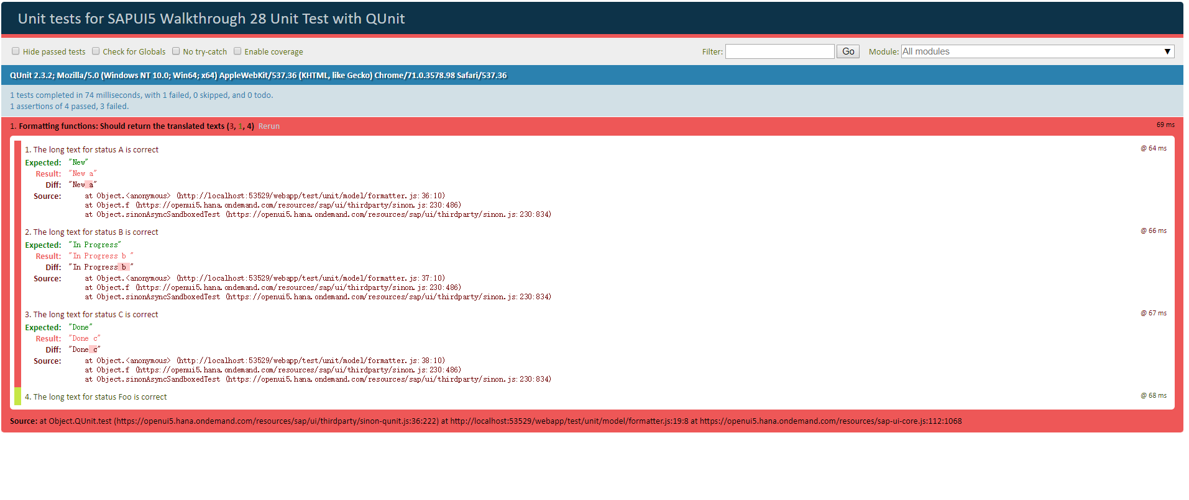

Git:

https://github.com/xiexiaop/SAPUI5-2-Round/tree/master/Projects/ZWALKTHROUGH_28

2019/02/06 XiaoMi Beijing Zac,Xie